Style Guide
Colour |  | RGB | HEX
 | primary | rgb(13, 109, 252) | #0d6dfc
 | primary-hover | rgb(8, 73, 168) | #0849A8
 | primary-disabled | rgb(97, 160, 255) | #61a0ff
 | danger | rgb(219, 53, 69) | #db3545
 | danger-hover | rgb(158, 38, 49) | #9E2631
 | aliceblue | rgb(240, 248, 255) | #F0F8FF
 | secondary | rgb(225, 235, 244) | #E1EBF4

S.No | Widgets | CSS Customizable
1 | page | ✓
2 | navbar | ✓
3 | navbar title | ✓
4 | search bar | ✓
5 | settings icon | ✓
6 | user list | ✓
7 | user profile image | ✓
8 | username | ✓
9 | user bio | ✓
10 | chat navbar | ✓
11 | back icon | ✓
12 | user profile image | ✓
13 | user name | ✓
14 | search bar | ✓
15 | search-btn | ✓
16 | chat-container | ✓
17 | clear-btn | ✓
18 | message | ✓
19 | sender name | ✓
20 | chat text | ✓
21 | timestamp | ✓
22 | message-input | ✓
23 | more icon | ✓
24 | message input field | ✓
25 | send-btn | ✓

3
15
chat navbar
BG: secondary
search bar
BG: white
username
Font-size: 25px

Search bar
BG: white
navbar title
Font-size: 25px
11
5
4
settings icon
Font-size: 25px
back icon
Font-size: 25px
12
user profile image
Shape: circle
13
10
14
search-btn
BG: outline-primary
Hover: primary

2
navbar
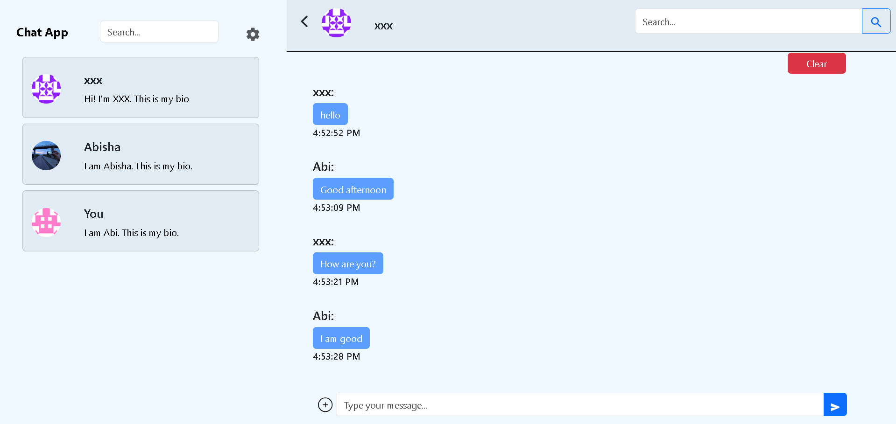
19
20
chat-text
BG: primary-disabled
Font-size: 15px
1
page
BG: aliceblue
user list
BG: secondary
6
user bio
Font-size: 15px
9
username
Font-size: 25px
8
24
22
message-input
message input field
BG: white
23
21
7
user profile image
Shape: circle
18
chat-container

16
message
send-btn
BG: primary
Hover: primary-hover
25
sender name
Font-size: 25px

timestamp
Font-size: 15px

17
clear-btn
BG: danger
Hover: danger-hover
more icon
Font-size: 25px

